UPT Backwards Compatibility
The CSM API and CSM User Provisioning Tool have been widely adopted by various applications within NCI CBIIT and other non-NCI applications. CSM UPT has been hosted commonly for applications to provision User security. The common hosting is done for the DEV, QA, STAGE and PROD tiers. Currently the CSM CSM UPT v4.0, CSM UPT 4.1 and CSM UPT 4.2 are commonly hosted on the four tiers. It has become a maintenance issue for the Systems Team to support multiple versions of CSM UPT on various tiers.
To avoid this hosting of multiple versions and a constant race to upgrading to later versions CSM, UPT introduced backward compatibility feature to allow users continue using old version installations with the single installation of latest version. This feature was introduced in CSM 4.2 supporting backwards compatibility to UPT 3.2, 4.0, and 4.1 versions. Installing CSM 4.2 would support provisioning earlier versions of UPT without upgrading them to 4.2 versions.
During Tech stack upgrade for 2011, it is decided that UPT would support backwards compatibility up to the UPT versions exist in the CBIIT technology stack. That is, according to 2011 CBIIT tech stack, UPT 4.2.3 would support UPT 4.1 and UPT 4.2 backward compatibility.
Design:
Each version of UPT application differs with each other due to functional, schema or technology version changes. In order to make one version work with different versions of UPT schema could become challenging. Even if it works, the UI for each version could differ as well. Due to this nature, UPT backwards compatibility design considered including backward UPT applications along with latest version of UPT. This way, UPT deployment can be customize itself based on requirement to support previous versions. Once the application is deployed, UPT will manage users logging into the application through its Login and Forward capability. UPT Login and Forwarding web application module authenticates users against the configured Credential Providers such as LDAP and RDBMS. UPT Login and Forwarding web application then checks if the user has authorization to access requested UPT application. Once the user is authorized, UPT Login and Forwarding web application forwards authenticated and authorized user to the requested version UPT application based on given application context.
Following diagram represent with high level design of the feature.

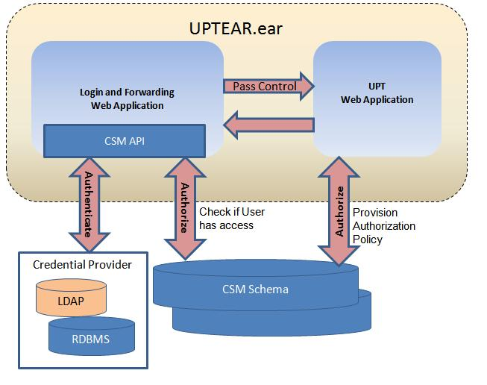

Following assumptions were made during the design
- The CSM schema for various versions could be on separate database servers.
- The UPT web applications will be installed in one container and tomcat clustering is not used.
- Only one application context name is used to for Authorization Policy provisioning per installation container. It is important assumption necessary to implement the solution the way it is designed. If there are applications with same name in different versions of CSM Schema then the first encountered match of application context name will be picked from a sequentially traversed list of UPT versions.
- Same user will need to be provisioned in Authentication database and authorization database.

Instructions to setup backward compatible UPT:
Following instructions assumes that you are using UPT 4.2.3 version with backward compatibility to UPT 4.2 and UPT4.1 applications. You need to have database for each of these applications setup and ready to use with installation process. You will need to change following properties in install.properties:
###################################
# upt backwards compatible multiple installation configuration #
###################################
upt.central.config=false
upt.41.installed=true
upt.42.installed=true
upt.423.installed=true

Update following database properties with correct values. You may not need to re-create 4.2 and 4.1 databases if they already exist, but properties for 4.2 and 4.1 should also be changed with correct values.

upt.423.database.re-create=true
#upt.423.database.drop-schema=true
upt.423.authentication.type=db

upt.423.database.type=${database.type}
upt.423.database.server=localhost
upt.423.database.version=5.1.0
upt.423.database.port=3306
upt.423.database.name=upt423
upt.423.database.system.user=uptadmin
upt.423.database.system.password=uptadmin
upt.423.database.user=upt423
upt.423.database.password=upt423
upt.423.database.encrypt.enabled=YES

upt.423.database.url.prefix=jdbc:mysql
upt.423.database.driver.class=org.gjt.mm.mysql.Driver
upt.423.database.dialect=org.hibernate.dialect.MySQLDialect
upt.423.database.system.url=${upt.423.database.url.prefix}://${upt.423.database.server}:${upt.423.database.port}
upt.423.database.url=${upt.423.database.system.url}/${upt.423.database.name}

Once these properties are updated, following SQL scripts has to be run.
In UPT 4.1 database:
update csm_application set application_name = 'csmupt41' where application_name='csmupt'
update csm_protection_element set protection_element_name='csmupt41', object_id='csmupt41' where protection_element_name='csmupt'
In UPT 4.2 database:
update csm_application set application_name = 'csmupt42' where application_name='csmupt'
update csm_protection_element set protection_element_name='csmupt42', object_id='csmupt42' where protection_element_name='csmupt'
In UPT 4.2.3 database:
update csm_application set application_name = 'csmupt423' where application_name='csmupt'
update csm_protection_element set protection_element_name='csmupt423', object_id='csmupt423' where protection_element_name='csmupt'

Run install process with “ant install” and the application should deployed and ready to use.
Notes:
When logging into UPT 4.2.3 as SuperAdmin, application context “csmupt423” should be used.
When logging into UPT 4.2 as SuperAdmin, application context “csmupt42” should be used.
When logging into UPT 4.1 as SuperAdmin, application context “csmupt41” should be used.
If you are creating an application user for UPT 4.2 or UPT 4.1, same user should also be created in UPT4.2.3, if you are using RDBMS authentication.

